**Devansh Shah**

**1914078**

**Exp 1 Lab work**

**Task 1**

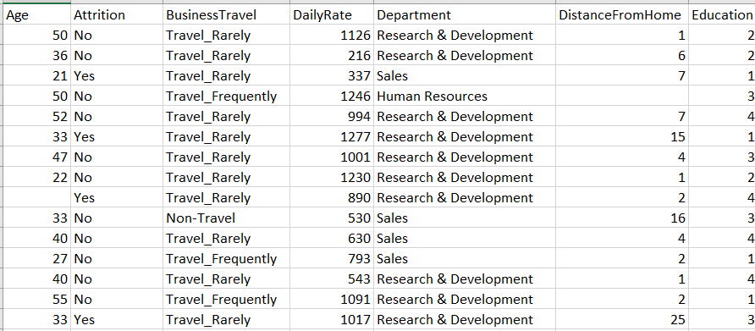

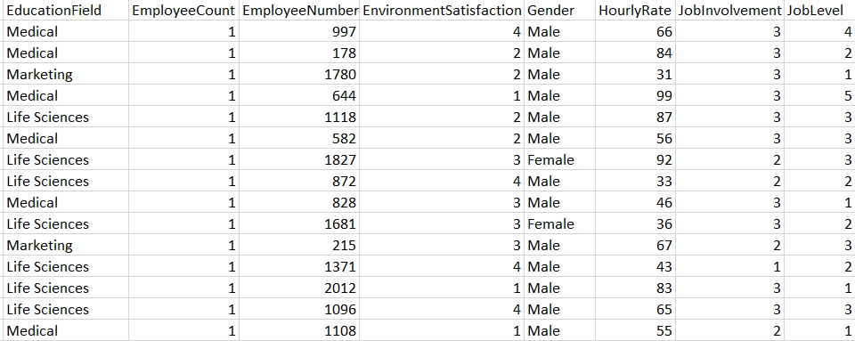

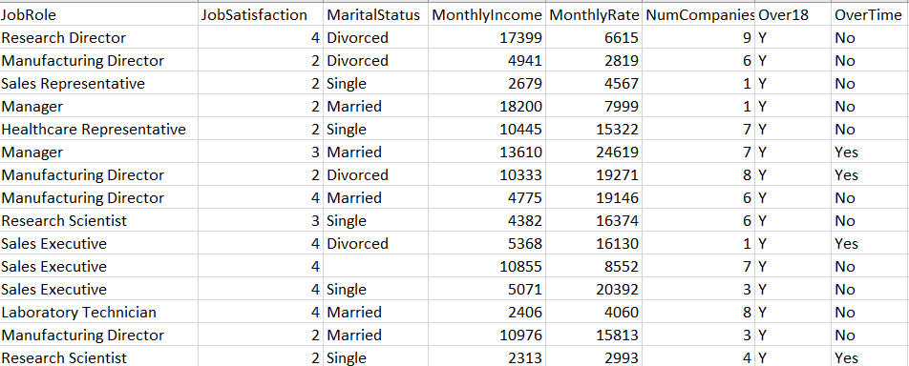

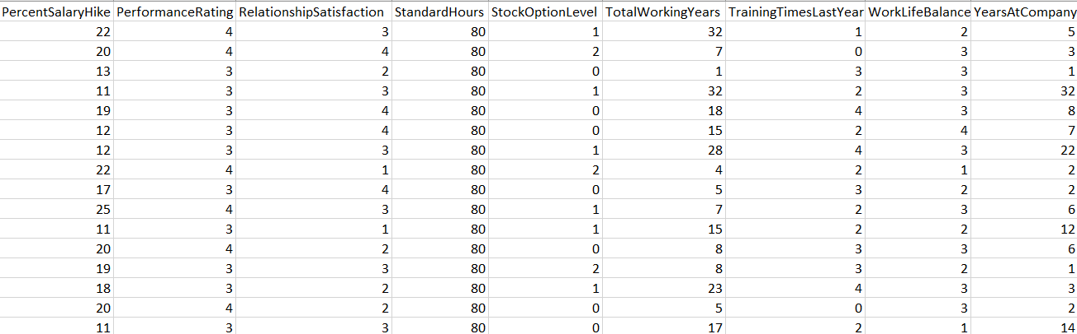

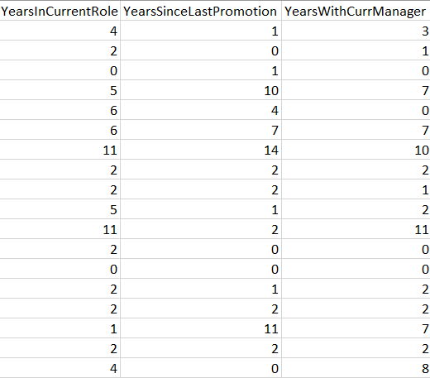

**Task 2**

|  |  |  |
| --- | --- | --- |
| **Column** | **Type** | **Attribute** |
| Age | Quantitative | Numeric |
| Attrition | Qualitative | Binary |
| BusinessTravel | Qualitative | Nominal |
| DailyRate | Quantitative | Numeric |
| Department | Qualitative | Nominal |
| DistanceFromHome | Quantitative | Numeric |
| Education | Quantitative | Numeric |
| EducationField | Qualitative | Nominal |
| EmployeeCount | Quantitative | Continuous |
| EmployeeNumber | Qualitative | Nominal |
| EnvironmentSatisfaction | Quantitative | Ratio |
| Gender | Qualitative | Binary |
| HourlyRate | Quantitative | Numeric |
| JobInvolvement | Quantitative | Ratio |
| JobLevel | Quantitative | Ratio |
| JobRole | Qualitative | Nominal |
| JobSatisfaction | Quantitative | Ratio |
| MaritalStatus | Qualitative | Binary |
| MonthlyIncome | Quantitative | Numeric |
| MonthlyRate | Quantitative | Numeric |
| NumCompaniesWorked | Quantitative | Numeric |
| Over18 | Qualitative | Binary |
| OverTime | Qualitative | Binary |
| PercentSalaryHike | Quantitative | Numeric |
| PerformanceRating | Quantitative | Ratio |
| RelationshipSatisfaction | Quantitative | Ratio |
| StandardHours | Quantitative | Continuous |
| StockOptionLevel | Quantitative | Ratio |
| TotalWorkingYears | Quantitative | Numeric |
| TrainingTimesLastYear | Quantitative | Numeric |
| WorkLifeBalance | Quantitative | Ratio |
| YearsAtCompany | Quantitative | Numeric |
| YearsInCurrentRole | Quantitative | Numeric |
| YearsSinceLastPromotion | Quantitative | Numeric |
| YearsWithCurrManager | Quantitative | Numeric |

**Task 3**

* MonthlyIncome, MonthlyRate, NumCompaniesWorked are important fields for knowing more information about the employee resume.
* EnvironmentSatisfaction, WorkLifeBalance, RelationshipSatisfaction, JobInvolvement, JobSatisfaction and StandardHours are key fields to know about the work ethic about the employee.
* YearsAtCompany, YearsInCurrentRole, YearsSinceLastPromotion, TotalWorkingYears, TrainingTimesLastYear and PerformanceRating gives important information regarding the efficiency of the employee.